28.79: a) Below the sheet, all the magnetic field contributions from different wires add up to produce a magnetic field that points in the positive x-direction. (Components in the z-direction cancel.) Using Ampere’s Law, where we use the fact that the field is anti-symmetrical above and below the current sheet, and that the legs of the path perpendicular provide nothing to the integral: So, at a distance beneath the sheet the magnetic field is:
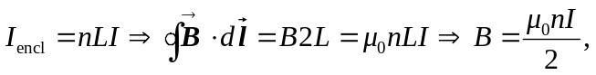

in the positive x-direction. (Note there is no dependence on a.)
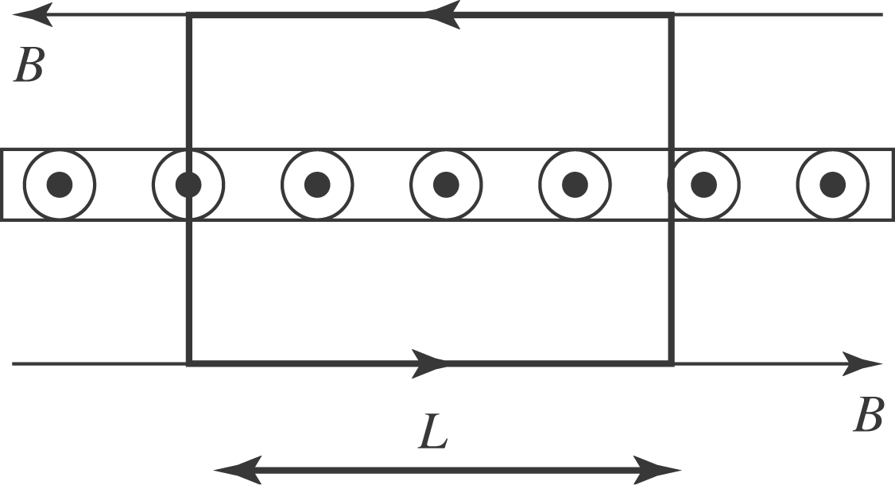

b) The field has the same magnitude above the sheet, but points in the negative x-direction.

